Display_Name..
Computer Programming Using Kivy - OpenGL 5 - Sound & Music
GOAL: Use sound in an event and music during init in a 3D scene.

(You must first have a completed and working opengl4.py)
Update the 3D engine:
- Go to your home drive (File Explorer, Computer, T:\username or H:)
- Go to your opengl folder, then double-click update-kivyglops

If you make a bump_glop event handler, you can use the name to determine what sound to play:
- Open Geany
- File, Open, your home drive (such as T:\username or H:), opengl, opengl4.py
- File, Save As, go to your opengl folder, then name this file opengl5.py
- To start the music then make crates able to be picked up, and have sound when used, add the following to your load_glops method, after your existing code which sets the other settings for item_dict (after typing the first add_bump_sound line below you can always just copy & paste that line then change the number for each):

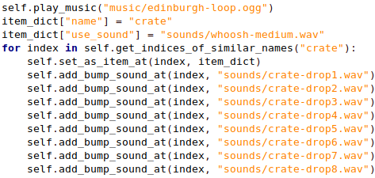
To make a sound play when you obtain something, in this case a different sound depending whether you (the bumper, which is in this case the player) obtain a barrel or a crate, implement the obtain_glop method in your MainScene class like this:
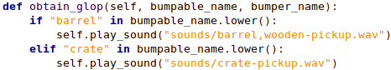

BONUS: Make the barrels also have a bump sound.

